**VALUER REPORT UID NO.:** **CEV/RVO/299/4619/19082025 19.08.2025**

**To**

**The AGM, RACPC SBI,**

**Sector 68, Mohali**

|  |  |  |  |  |  |  |  |
| --- | --- | --- | --- | --- | --- | --- | --- |
| **I** | **General** | | | |  |  | |
| 1. | Purpose for which the valuation is made | | | | : | **Bank’s purpose** | |
| 2. | A | Date of Inspection | | | : | 19.08.2025 | |
| B | Date on which the Valuation is made | | | : | 19.08.2025 | |
| 3. | List of documents produced for perusal | | | |  |  | |
| (i) Agreement to sell | | | |  | ATS dated 11.08.2025 between  **Seller:** M/s SAV INFOSYSTEMS LLP  **Buyer:** Mrs. Anisha Tandon W/o Mr. Virat Khanna | |
|  | (ii) Allotment letter | | | |  | Dt. 11.08.2025 in the name of Mrs. Anisha Tandon W/o Mr. Virat Khanna | |
| 4. | Name of the owner(s) and his/their address(es) with Phone no. (details of share of each owner in case of joint ownership) | | | | : | **Mrs. Anisha Tandon W/o Mr. Virat Khanna**  **Ph. No. 9878583636** | |
| 4A | Name of the Client /Borrower | | | |  | **Mrs. Anisha Tandon W/o Mr. Virat Khanna** | |
| 5 | Brief description of the property (including leasehold/freehold etc) | | | | : | **Unit No. 31/4, type-A, 4th Floor, Tower-31, Gulnaar Meadows, Vill. Baltana, Tehsil Zirakpur, Dist. Mohali, Pb.**  **Freehold** | |
| 6 | Location of Property | | | | : |  | |
| a) | | Plot No./Survey No. | | : | Unit No. 31/4, type-A, 4th Floor, Tower-31, Gulnaar Meadows | |
| b) | | Door No. | | : | Unit No. 31/4, type-A, 4th Floor, Tower-31, Gulnaar Meadows | |
| c) | | T.S. No./Village | | : | Vill. Baltana | |
| d) | | Ward/Taluka/Tehsil | | : | Zirakpur | |
| e) | | Mandal/District | | : | Mohali | |
|  | f) | | Date of issue and validity of layout of approved map/plan | | : | NA | |
|  | g) | | Approved map / plan issuing authority | | : | MC Zirakpur | |
|  | h) | | Whether genuineness or authenticity of approved map/plan is verified | | : | As per MC Zirakpur | |
|  | i) | | Any other comments by our empaneled valuers on authenticity of approved plan | | : | No | |
| 7. | Postal address of the property | | | | : | **Unit No. 31/4, type-A, 4th Floor, Tower-31, Gulnaar Meadows, Vill. Baltana, Tehsil Zirakpur, Dist. Mohali, Pb.** | |
| 8 | City/Town | | | | : | Town | |
| Residential Area | | | | : | Yes | |
| Commercial Area | | | | : | No | |
| Industrial Area | | | | : | No | |
| 9 | Classification of the area | | | |  | - | |
| i) | High/Middle/Poor | | | : | Middle | |
| ii) | Urban/Semi Urban/Rural | | | : | Semi-Urban | |
| 10 | Coming under Corporation limit/Village Panchayat/ Municipality | | | | : | MC Zirakpur | |
| 11 | Whether Carpet under any State/ Central Govt. enactments (e.g. Urban Land Ceiling Act) or notified under agency area / Scheduled area / cantonment area. | | | | : | Legal opinion in this regard may be taken from legal counsel of the bank | |
| 12 | Boundaries of the property | | | | : | **As per sale deed** | **As per Actuals** |
| North | | | | : | - |  |
| South | | | | : | - |  |
| East | | | | : | - |  |
| West | | | | : | - |  |
| 13 | **Dimensions of the site** | | | | : | **As Per Sale deed** | **As per Actuals** |
|  | North | | | |  | - | - |
| South | | | |  | - | - |
| East | | | |  | - | - |
| West | | | |  | - | - |
| 14 | Extent of the site | | | | : | Carpet Area= 984.125 sft as per allotment letter | |
| 14.1 | Latitude, Longitude and Coordinates of the site | | | | : | **Lats. 30.648904 N & Long. 76.790792 E** | |
| 15 | Extent of the site considered for valuation (least of 14 A & 14 B) | | | | : | Carpet Area= 984.125 sft | |
| 16 | Whether occupied by the owner / tenant? If occupied by tenant, since how long? Rent received per month. | | | | : | Owner Occupied | |
| **II.** | **APPARTMENT BUILDING** | | | |  |  | |
| 1. | Nature of the Apartment | | | | : | Unit No. 31/4 | |
| 2. | Location | | | | : | Unit No. 31/4, type-A, 4th Floor, Tower-31, Gulnaar Meadows, Vill. Baltana, Tehsil Zirakpur, Dist. Mohali, Pb. | |
|  | T. S. No. | | | | : | - | |
|  | Block No. | | | | : | - | |
|  | Ward No. | | | | : | - | |
|  | Village/Municipality/Corporation | | | | : | MC Zirakpur | |
|  | Door No., Street or Road (Pin Code) | | | | : | - | |
| 3. | Description of the locality Residential / Commercial / Mixed | | | | : | Residential | |
| 4. | Year of Construction | | | | : | Under Finishing | |
| 5. | Number of floors | | | | : | 4 Floors | |
| 6. | Type of Structure | | | | : | RCC framed | |
| 7. | Number of Dwelling units in the building | | | | : | Not mentioned in docs | |
| 8. | Quality of construction | | | | : | Good | |
| 9. | Appearance of the building | | | | : | Good | |
| 10. | Maintenance of the Building | | | | : | Good | |
| 11. | Facilities Available | | | |  |  | |
|  | Lift | | | | : | Yes | |
|  | Protected Water Supply | | | | : | Yes | |
|  | Underground Sewerage | | | | : | Yes | |
|  | Car Parking - Open/ Covered | | | | : | Yes | |
|  | Is Compound wall existing? | | | | : | Yes | |
|  | Is pavement laid around the building | | | | : | Yes | |
| **III.** | **FLAT** | | | |  |  | |
| 1. | The floor on which the flat is situated | | | | : | Fourth Floor | |
| 2. | Door No. of flat | | | | : | 31/4 | |
| 3. | Specifications of the flat | | | | : | - | |
| Roof | | | | : | Roof slab | |
| Flooring | | | | : | Tiles | |
| Doors | | | | : | Hard Wood | |
| Windows | | | | : | Hard Wood | |
| Fittings | | | | : | Ordinary | |
| Finishing | | | | : | OBD | |
| 4 | House tax | | | | : | With owner | |
| Assessment No. | | | | : | With owner | |
| Tax paid in the name of | | | | : | With owner | |
| Tax amount | | | | : | With owner | |
| 5. | Electricity Service Connection no. | | | | : | With owner | |
| Meter Card is in the name of | | | | : | With owner | |
| 6. | How is the maintenance of the flat? | | | | : | With owner | |
| 7. | What is the undivided area of land as per Sale Deed | | | | : | NA | |
| 8. | What is the plinth area of the flat? | | | | : | Carpet area -984.125 sft | |
| 9. | What is the floor space index (app.) | | | | : | Not mentioned in docs | |
| 10. | What is the Carpet Area of the flat? | | | | : | 984.125 sft | |
| 11. | Is it Posh/ I class / Medium / Ordinary? | | | | : | Medium | |
| 12. | Is it being used for Residential or Commercial purpose? | | | | : | Residential | |
| 13. | Is it Owner-occupied or let out? | | | | : | Owner-occupied | |
| 14. | If rented, what is the monthly rent? | | | | : | NA | |
| **IV MARKETABILITY** | | | | |  |  | |
|  | 1 | | How is the marketability? | | : | Normal | |
| 2 | | What are the factors favoring for an extra potential value? | | : | Not special | |
| 3 | | Any negative factors are observed which affect | | : | NA | |
| **V Rate** | | | | |  |  | |
|  | 1 | | After analyzing the comparable sale instances, what is the composite rate for a similar flat with same specifications in the adjoining locality?–(Along with details /reference of at-least two latest deals/transactions with respect to adjacent properties in the areas) | | : | Sale instances are not available, however on detailed inquiry with property consultants working in this area, it is observed that similar flats are available in the range of Rs 11500/- per sft to 12000/-per sft. of Carpet Area (Composite rate of land and building) | |
| 2 | | Assuming it is a new construction, what is the adopted basic composite rate of the flat under valuation after comparing with the specifications and other factors with the flat under comparison (give details). | | : | Rs 11500/- per sft. of Carpet Area (Composite rate of land and building adopted) | |
| 3 | | Break - up for the rate | |  | - | |
|  | | | i) | Building + Services | : | NA | |
| ii) | Land + Others | : | NA | |
|  | 4 | | Guideline rate obtained from the Registrar's office  (an evidence thereof to be enclosed) | | : | **Rs. 3200/- per sft. (copy attached)** | |
| **VI.** | **COMPOSITE RATE ADOPTED AFTER DEPRECIATION** | | | |  |  | |
| a. | Depreciated building rate | | | |  |  | |
|  | Replacement cost of flat with Services {V (3)i} | | | | : | Rs 11500/- per sft. of Carpet Area (Composite rate of land and building adopted) | |
|  | Age of building | | | | : | Under Finishing | |
|  | Life of building estimated | | | | : | 70 years with periodic maintenance | |
|  | Depreciation percentage assuming the salvage value as 10% | | | | : | 1.285 % P.A., | |
|  | Depreciated Rate of the building | | | | : | Considered in composite rate adopted | |
| b. | Total composite rate arrived for valuation | | | | : | Rs 11500/- per sft. of Carpet Area (Composite rate of land and building adopted) | |
|  | Depreciated building rate VI (a) | | | | : | Rs 11500/- per sft. of Carpet Area (Composite rate of land and building adopted) | |
|  | Rate for Land &other V (3) ii | | | | : |
|  | Total Composite Rate | | | | : | Rs 11500/- per sft. of Carpet Area (Composite rate of land and building adopted) | |
|  | **Insurable Value of unit** | | | |  | Carpet area, 984.125 sft * 2200= Rs. 21,65,075 /- **say Rs. 21.65 Lac** | |

**Details of Valuation:**

|  |  |  |  |  |
| --- | --- | --- | --- | --- |
| **S. No.** | **Description** | **Qty.** | **Rate per unit**  **Rs.** | **Estimated value**  **Rs.** |
| 1. | Value of the flat (incl. car parking, if provided | Carpet area -984.125 sft | Rs11500/- per sft. of Carpet Area (Composite rate of land and building adopted) | 1,13,14,437.5/- |
| 2. | Wardrobes | - | - | - |
| 3. | Showcases | - | - | - |
| 4. | Kitchen arrangements | - | - | - |
| 5. | Superfine finish | - | - | - |
| 6. | Interior decorations | - | - | - |
| 7 | Electricity deposits/electrical fittings, etc. | - | - | - |
| 8. | Extra collapsible gates/grill works etc. | - | - | - |
| 9. | Potential value, if any | - | - | - |
| 10. | Others | - | - | - |
|  | **Total value of flat** | - | - | **Say Rs. 113.15 lac** |

**Details of Valuation:**

Note: The Valuation has been made adopting market approach for the **value of unit** compared from similar properties situated in the same locality or in vicinity as the property is being used for personal residence and not income generating and freely marketable. Price of such property searched from web site of housing.com, magicbricks.com, 99acres.com etc. Average rate of 3 similar similar/ comparable available property considered as also verified personally from local real estate dealers & neighbors. There is huge gap in book value of the property as per Collector rates and fair market value prevailing as on date of the above property. Sale instances of prevailing market rates cannot be made available as people are always interested in saving the stamp duty and hence get the property registered at the Collector rates only which are much less than the market value.

**Justification for variation in the GLR & Market Rates:** Property has been valued at the prevailing market rate. I am of the considered opinion that the rate in Basic Valuation Register is not an evidence to determine the market value. The register maintained by the Registrar for registering the sale deeds is only for collection of stamp duty and has no statutory base, so it cannot form any basis to determine the market value. **Hon’ble Court orders viz. JAWAJEE NAGANATHAN V/S REVENUE DIVISION OFFICER, STATE OF PUNJAB V/S MAHABIR SINGH (SUPREME COURT, 1996) and LAL CHAND V/S UNION OF INDIA (SUPREME COURT, 1996)** may be referred. However copy of rates as available on real estate websites like “99 acres.com, magicbricks.com and housing .com” etc. are appended herewith for reference.

In case the valuation report submitted by the valuer is not in order, the Bank must bring the same to the notice of the valuer within 15 days of submission for rectification and resubmission. In case no such communication is sent, it shall be presumed that the valuation report has been accepted.

Also, such aspects as:

i) Sale ability: Depends on demand, varying from time to time.

ii) Rental values: Depends on demand & supply

1. Photograph of owner/representative with property in background enclosed

2. Screen shot of longitude/latitude and co-ordinates of property using GPS/Various Apps/Internet sites.

**As a result of my appraisal and analysis, it is my considered opinion that various values of the above property in the prevailing conditions with aforesaid specifications are:**

**1. Present Market value is Rs. 113.15 lac (Rs. One crore thirteen Lac fifteen thousand only).**

**2. Realizable value is Rs. 101.84 Lac (Rs. One crore one Lac eighty four thousand Only).**

**3. Distress value is Rs. 84.86 Lac (Rs. Eighty four Lac eighty six thousand Only).**

**Place: Panchkula**

**Date: 19.08.2025 Signature of Valuer**

**(Name of the Valuer with office seal)**

The undersigned has inspected the property detailed in the Valuation Report dated­­­­­­­­­­­­­­­­­­­­­­­­­­­­________________on __________________.We are satisfied that the fair & reasonable market value of the property is Rs. ____________________(Rs._______________________________only)

**Signature**

**(Name of the Branch Manager with Office Seal)**

**Collector Rates for Tehsil Zirakpur for year 2024-25**



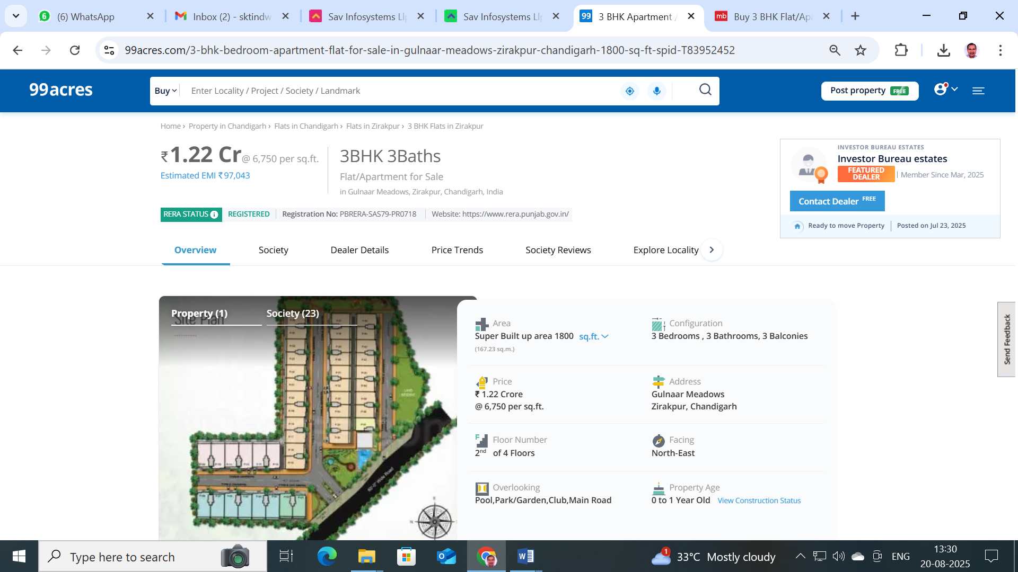

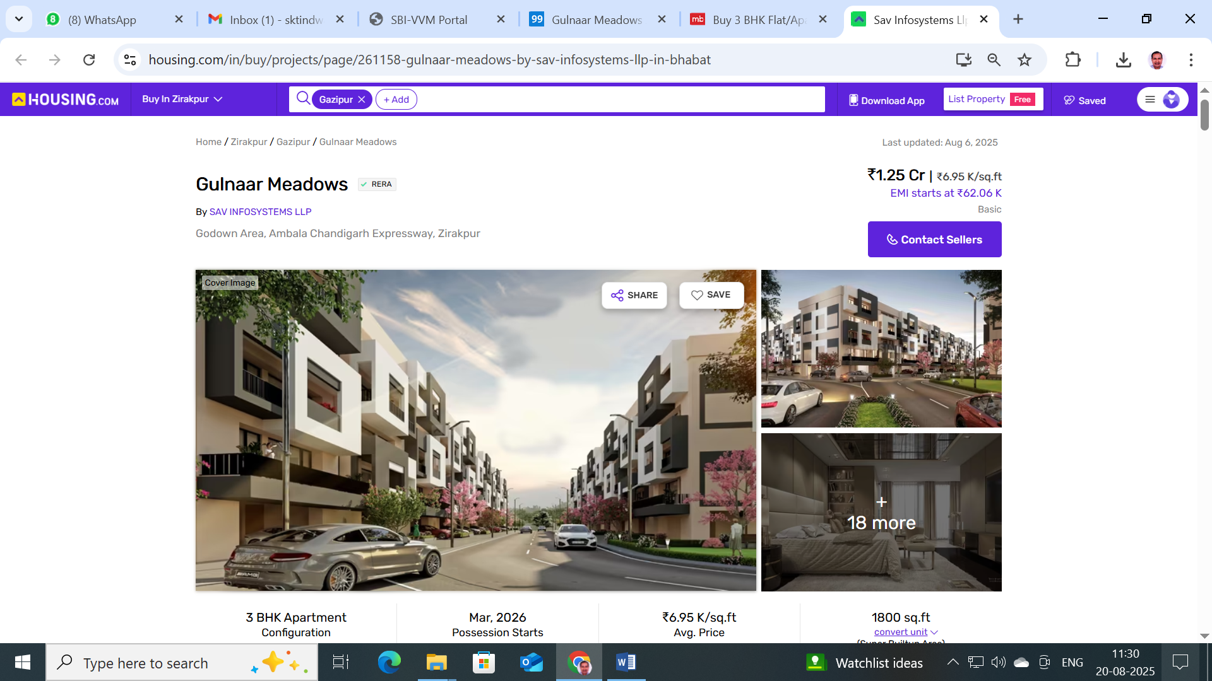

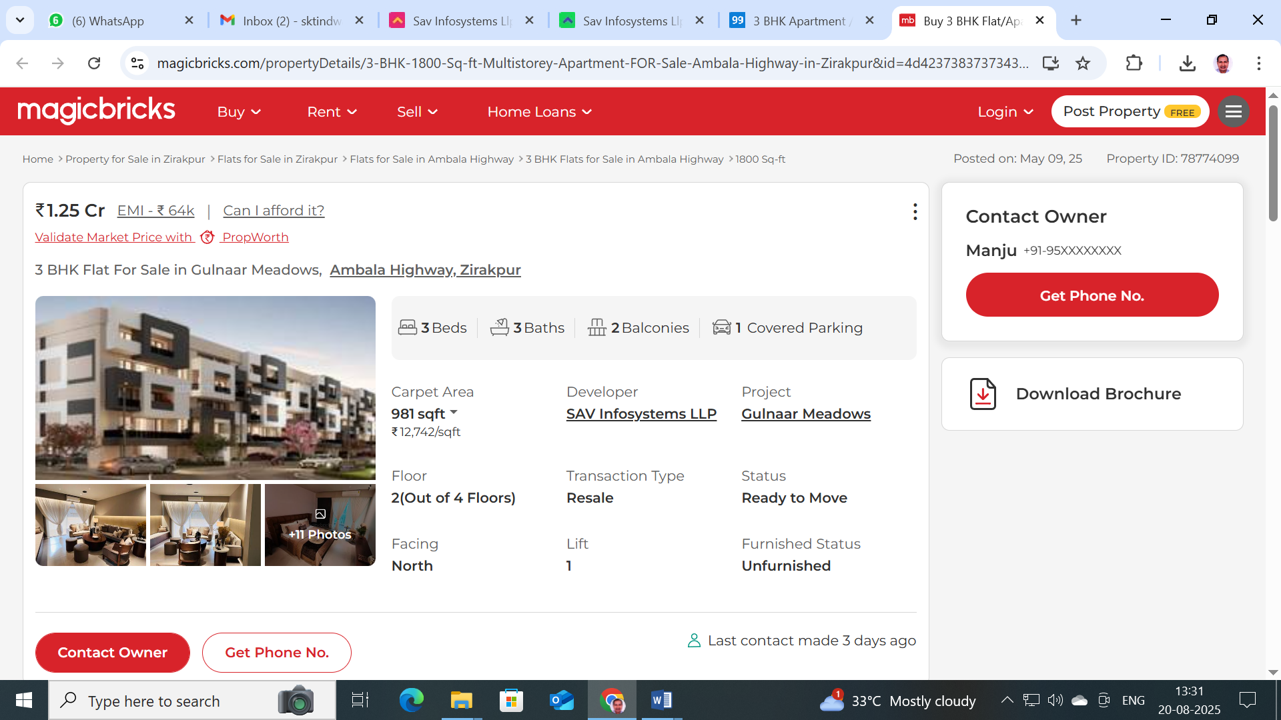

**Photos of Unit No. 31/4, Type-A, 4th Floor, Tower-31, Gulnaar Meadows, Vill. Baltana, Tehsil Zirakpur, Dist. Mohali, Pb.**

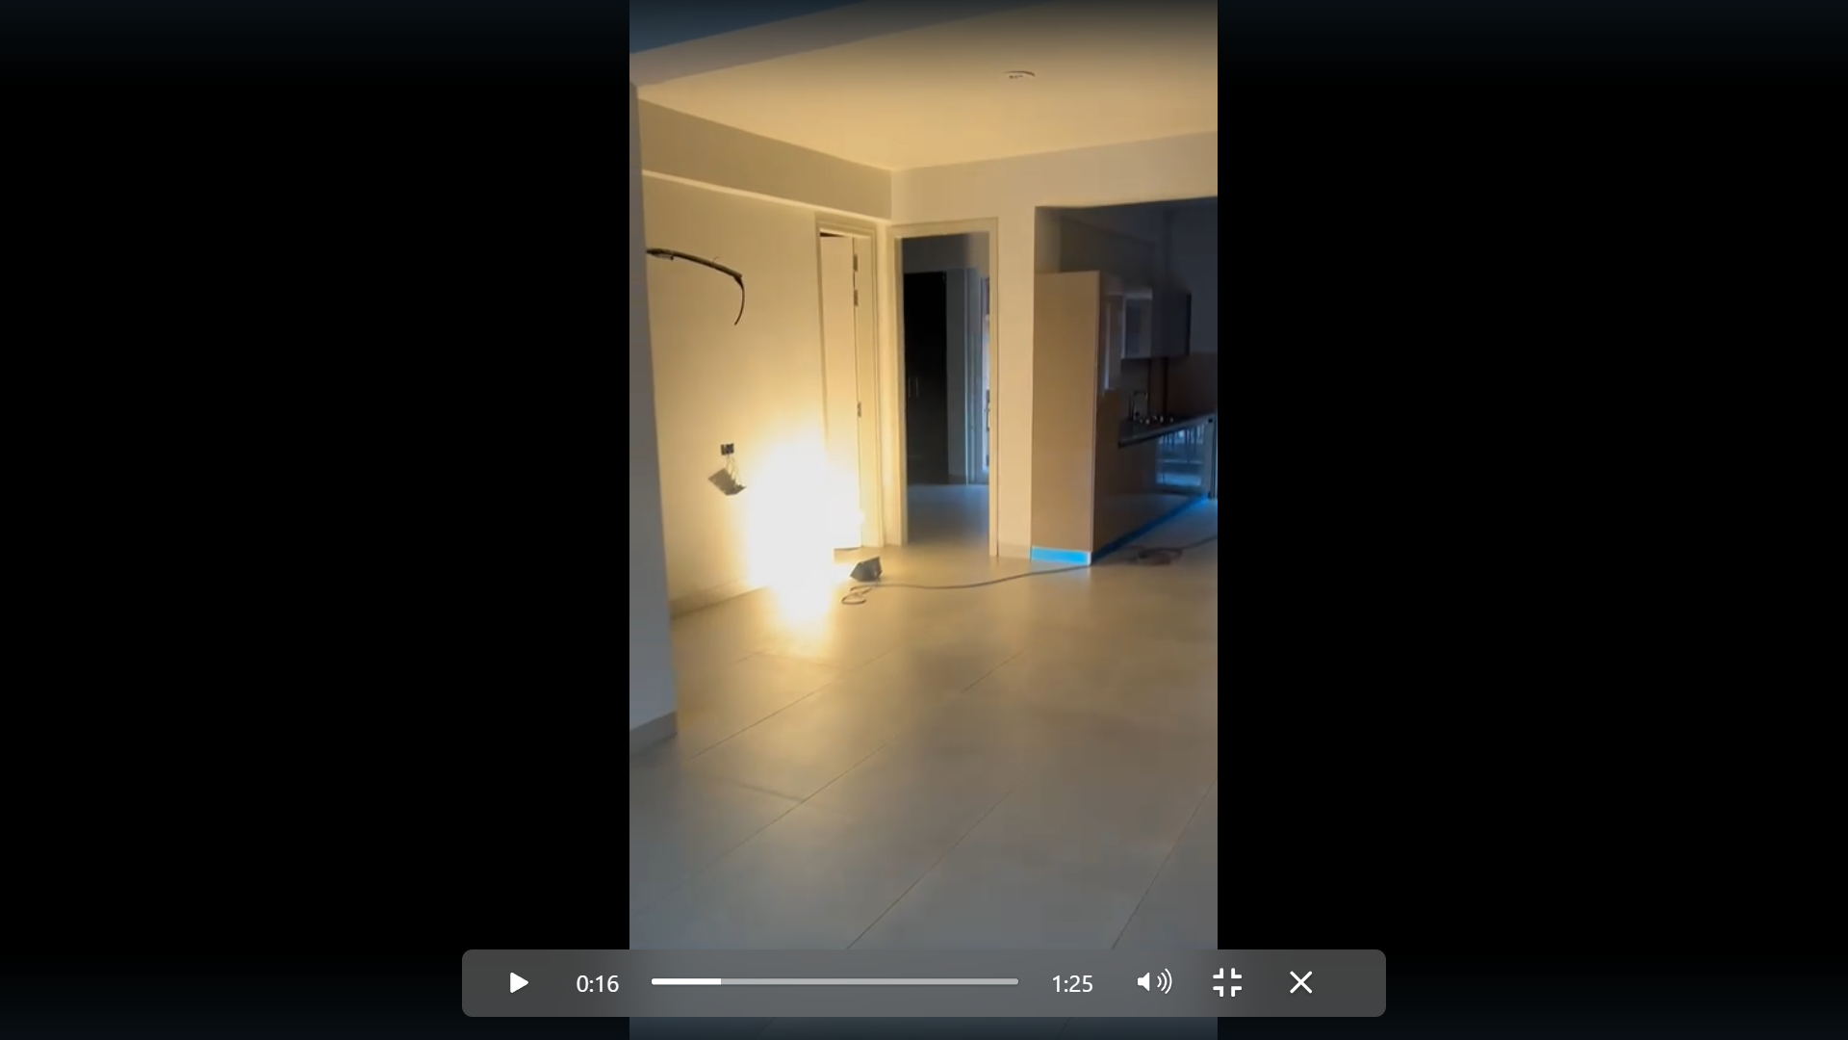 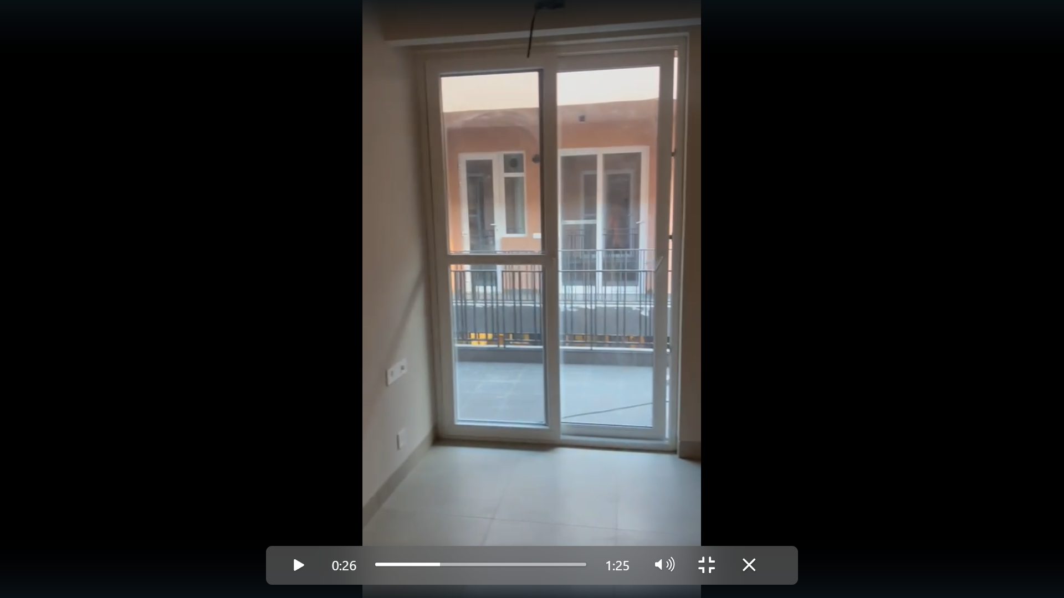 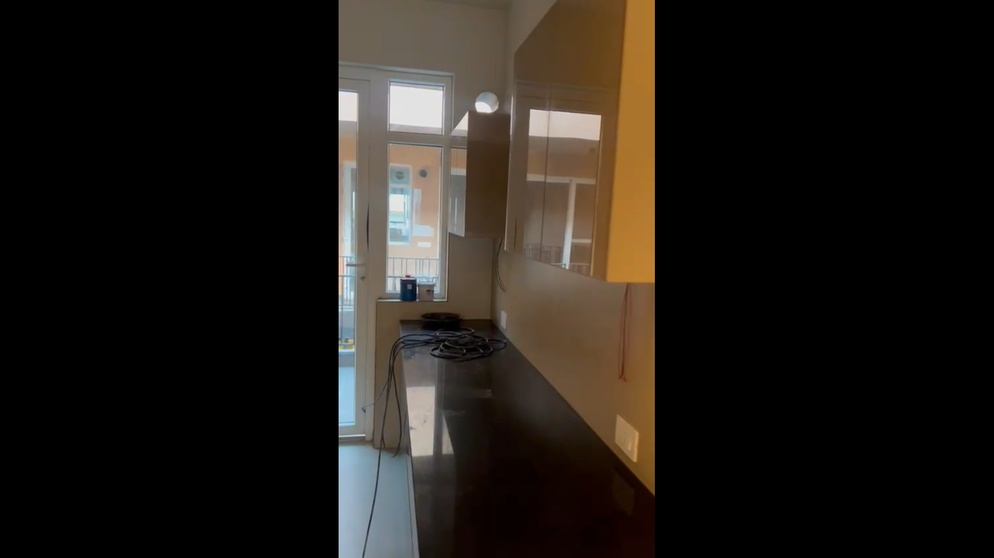

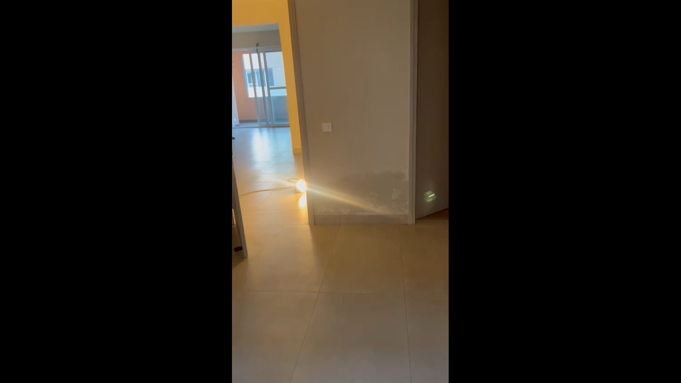 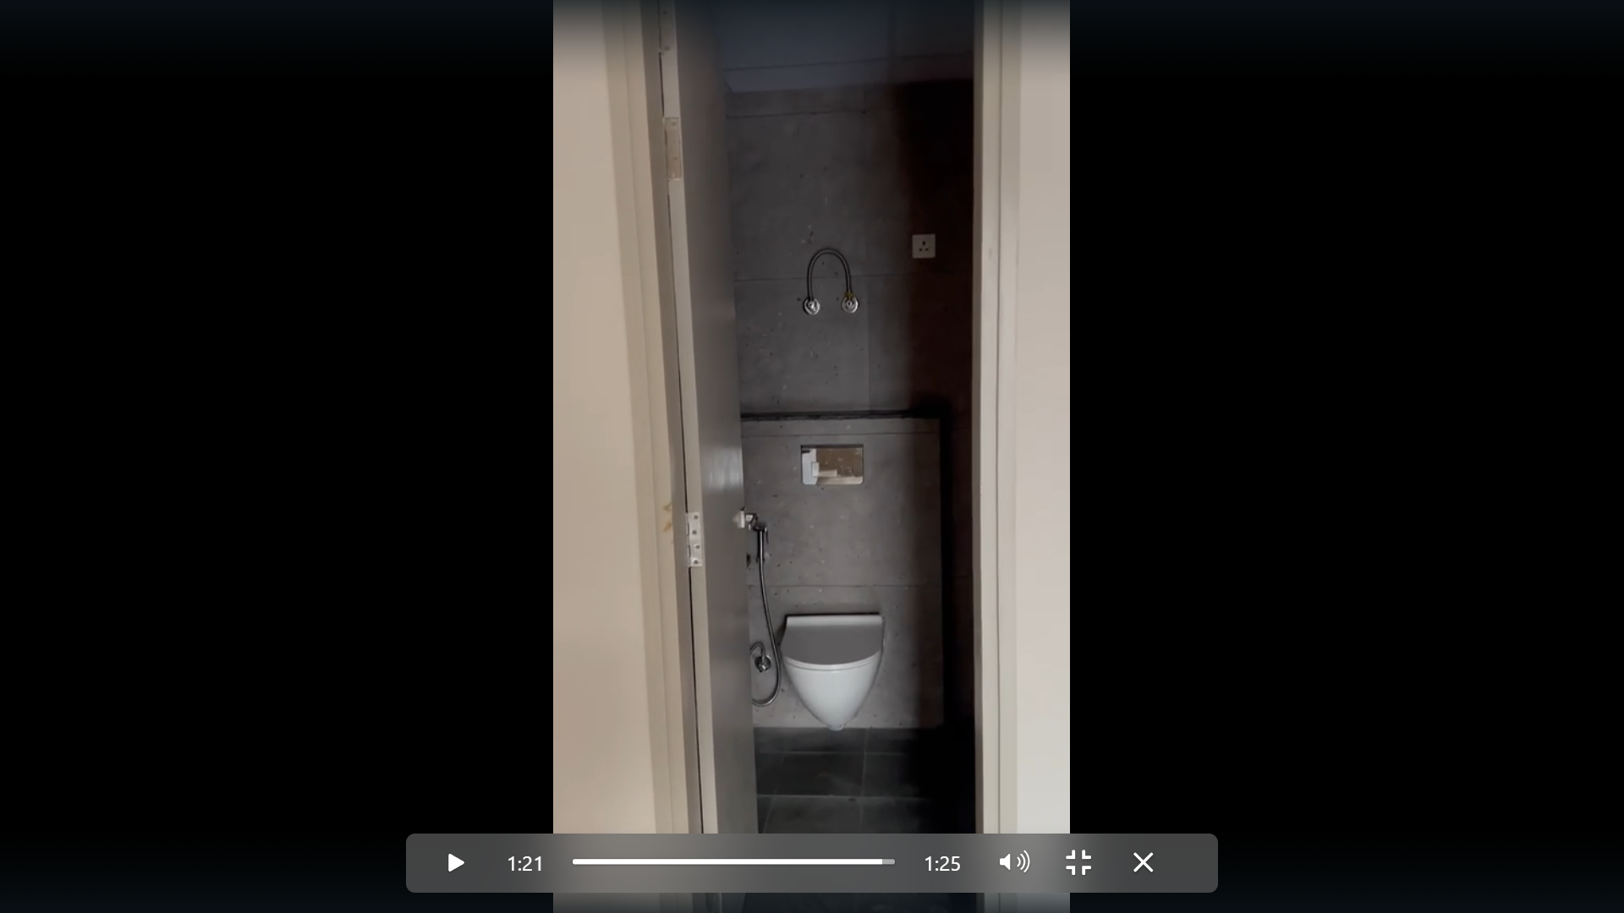

**Google Location**

**Annexure-I**

**Format of undertaking to submitted by Individuals/proprietor/partners/direction DECLARATION-CUM-UNDERTAKING**

I, Surinder Kumar Tindwal son of Late Sh. Chhelu Ram do hereby solemnly affirm and state that: a. I am a citizen of India b. I will not undertake valuation of any assets in which I have a direct or indirect interest or become so interested at any time during a period of three years prior to my appointment as valuer or three years after the valuation of assets was conducted by me c. The information furnished in my valuation report dated DD.MM.YYYY is true and correct to the best of my knowledge and belief and I have made an impartial and true valuation of the property. d. I have personally inspected the property on DD.MM.YYYY The work is not subcontracted to any other valuer and carried out by myself. e. Valuation report is submitted in the format as prescribed by the Bank f. I have not been depaneled/ delisted by any other bank and in case any such depanelment by other banks during my empanelment with you, I will inform you within 3 days of such depanelment. f. I have not been removed/dismissed from service/employment earlier g. I have not been convicted of any offence and sentenced to a term of imprisonment h. I have not been found guilty of misconduct in professional capacity L have not been declared to be unsound mind J. I am not an undischarged bankrupt, or has not applied to be adjudicated as a bankrupt; k. I am not an undischarged insolvent L. I have not been levied a penalty under section 2711 of Income-tax Act, 1961 (43 of 1961) and time limit for filing appeal before Commissioner of Income tax (Appeals) or income-tax Appellate Tribunal, as the case may be has expired, or such penalty has been confirmed by Income-tax Appellate Tribunal, and five years have not elapsed after levy of such penalty m. I have not been convicted of an offence connected with any proceeding under the Income Tax Act 1961, Wealth Tax Act 1957 or Gift Tax Act 1958 and n. My PAN Card number/Service Tax number as applicable is o. I undertake to keep you informed of any events or happenings which would make me ineligible for empanelment as a valuer.

I have not concealed or suppressed any material information, facts and records and I have made a complete and full disclosure q. I have read the Handbook on Policy, Standards and procedure for Real Estate Valuation, 2011 of the IBA and this report is in conformity to the "Standards" enshrined for valuation in the Part-B of the above handbook to the best of my ability r. I have read the International Valuation Standards (IVS) and the report submitted to the Bank for the respective asset class is in conformity to the "Standards" as enshrined for valuation in the IVS in "General Standards" and "Asset Standards" as applicable s. I abide by the Model Code of Conduct for empanelment of valuer in the Bank (Annexure V-A signed copy of same to be taken and kept along with this declaration) t. I am registered under Section 34 AB of the Wealth Tax Act, 1957. (Strike off, if not applicable) u. I am valuer registered with Insolvency & Bankruptcy Board of India (IBBI) (Strike off, if not applicable) v. My CIBIL Score and credit worthiness is as per Bank's guidelines, w. I am the proprietor/partner/authorized official of the firm/company, who is competent to sign this valuation report. x. I will undertake the valuation work on receipt of Letter of Engagement generated from the system (i.e. LLMS/LOS) only. y. Further, I hereby provide the following information.

|  |  |  |
| --- | --- | --- |
| **Sl No.** | **Particulars** | **Valuer’s comment** |
| 1 | background information of the asset being valued; | **Unit No. 31/4, type-A, 4th Floor, Tower-31, Gulnaar Meadows, Vill. Baltana, Tehsil Zirakpur, Dist. Mohali, Pb** |
| 2 | purpose of valuation and appointing authority | Bank’s purpose |
| 3 | identity of the valuer and any other experts involved in the valuation; | Surinder Kumar Tindwal |
| 4 | disclosure of valuer interest or conflict, if any; | No |
| 5 | date of appointment, valuation date and date of report: | 19.08.2025, 19.08.2025, 19.08.2025 |
| 6 | inspections and/or investigations undertaken; | Inspection on 19.08.2025 and meeting/ discussion/inquiry with property consultants of the area |
| 7 | nature and sources of the information used or relied upon; | Real estate web portals and property consultants of the area |
| 8 | procedures adopted in carrying out the valuation and valuation standards followed; | Market approach adopted being the property non income fetching and marketable |
| 9 | restrictions on use of the report, if any; | For exclusive use of SBI RACPC, Sec-68, Mohali and no other else. |
| 10 | major factors that were taken into account during the valuation; | Location, size, direction, frontage along road, specifications used in building and workmanship |
| 11 | major factors that were not taken into account during the valuation; | NA |
| 12 | Caveats, limitations and disclaimers to the extent they explain or elucidate the limitations faced by valuer, which shall not be for the purpose of limiting his responsibility for the valuation report. | **i**. I/We have not verified the title deeds of the properties with the records of registrar’s office as this is beyond the agreed scope of our services stated in our engagement letter.  ii. I/We assume no responsibility for the legal matters including, but not limited to, legal or title concerns. The assets and interests therein have been valued free and clear of any liens or encumbrances unless stated otherwise. No hidden or apparent conditions regarding the subject assets or their ownership are assumed to exist. No opinion of title is rendered by this report and a good title is assumed.  iii. The RV has endeavoured to visually identify the land boundaries and dimensions; however, he is not a surveyor. So where there is a doubt about the precise position of the structures, it is recommended that a Licensed Surveyor be contacted.  iv. The physical condition of the improvements was based on visual inspection. No liability is assumed for the soundness of the structure since no engineering tests were made at the site. Any unknown conditions existing at the time of inspection could alter the value. No responsibility is assumed for latent defects of any nature whatsoever, which may affect value, nor for any expertise required to disclose such conditions.  v. Where a sketched plan is attached to this report, it does not purport to represent accurate architectural plans. Sketch plans and photographs are provided as general illustrations only.  vi. Unless otherwise stated as part of the terms of engagement, the RV has not made a specific compliance survey or analysis of the various permits and licenses under central, state and local laws / regulations applicable to the operation and use of the subject property, and this valuation does not consider the effect, if any, of non-compliance.  vii. The sale of the subject property is assumed to be on an all cash basis. Financial arrangements would affect the price at which the property may sell for if placed on the market.  viii. Value varies with the purpose and date. This report is not to be referred if the purpose is different other than mentioned.  ix. The actual realizable value that is likely to be fetched upon sale of the property under consideration shall entirely depend on the demand and supply of the same in the market at the time of sale.  x. In the course of the valuation, we were provided with both written and verbal information. We have however, evaluated the information provided to us by the Company through broad inquiry, analysis and review but have not carried out a due diligence or audit of the information provided for the purpose of this engagement. Our conclusions are based on the assumptions, forecasts and other information given by/on behalf of the Company.  xi. We are independent of the client/company and have no current or expected interest in the Company or its assets. The fee paid for our services in no way influenced the results of our analysis.  xii. Our report is meant for the purpose mentioned above and should not be used for any purpose other than the purpose mentioned therein. The Report should not be copied or reproduced without obtaining our prior written approval for any purpose other than the purpose for which it is prepared. |

Date:19.08.2025

Place: Panchkula

**Signature**

**(Name of the approved valuer and seal of the Firm/company)**

**Annexure -II**

**MODEL CODE OF CONDUCT FOR VALUERS**

All the empaneled Valuers are required to adhere to the code of conduct given as under:

**Integrity and Fairness:**

1. A Valuer shall, in the conduct of his/its business, follow high standards of integrity and fairness in all its dealings with his/its clients and other Valuers

2. A Valuer shall maintain integrity by being honest, straightforward, and forthright in all professional relationships.

3. A Valuer shall endeavor to ensure that he/it provides true and adequate information and shall not misrepresent any facts or situations.

4. A Valuer shall refrain from being involved in any action that would bring disrepute to the profession.

5. A Valuer shall keep public interest foremost while delivering his services.

**Professional Competence and Due Care:**

6. A Valuer shall render at all times high standards of service, exercise due diligence, ensure proper care and exercise independent professional judgments

7. A Valuer shall carry out professional service in accordance with the relevant technical and professional standards that may be specified from time to time.

8. A Valuer shall continuously maintain professional knowledge and skills to provide competent professional service based on up to date developments in practice, prevailing regulations/guidelines and techniques.

9. In the preparation of a Valuation report, the Valuer shall not disclaim liability for his/its expertise or deny his/its/duty of care, except to the extent that the assumptions are based on statements of fact provided by the company or its auditors or consultants or information available in public domain and not generated by the Valuer

10. A Valuer shall not carry out any instructions of the client insofar as they are incompatible with the requirements of integrity. objectivity and independence.

11. A Valuer shall clearly state to his client the services that he would be competent to provide and the services for which he would be relying on other Valuers or professionals or for which the client can have a separate arrangement with other Valuers.

**Independence and Disclosure of Interest:**

12. A Valuer shall act with objectivity in his fits professional dealings by ensuring that his/its decisions are made without the presence of any bias, conflict of interest, coercion, or undue influence of any party, whether directly connected to the Valuation assignment or not.

13. A Valuer shall wherever necessary disclose to the clients, possible sources of conflicts of duties and interest providing un biased services

14. A Valuer shall maintains complete independence in his/its professional relationships and shall conduct the Valuation independent of external influences

15. A Valuer shall not deal in securities of any subject company after any time when he/it first becomes aware of the possibility of his/its association with the Valuation, and in accordance with Bank of India the Securities and Exchange Board of India (Prohibition of Insider Trading) Regulations, 2015 or till the time the Valuation report becomes public, whichever is earlier.

16. A Valuer shall not indulge in mandate snatching or offering 'convenience Valuations' in order to cater to a company or client's needs

17. As an independent Valuer, the Valuer shall not charge success fee (success may be defined as a compensation/ incentive paid to any third party for successful closure of transaction. In this case, approval of credit proposals).

18. In any fairness opinion or independent expert opinion submitted by a Valuer, if there has been a prior engagement in an unconnected transaction, the Valuer shall declare the association with the company during the last five years.

**Confidentiality:**

19. A Valuer shall not use or divulge to other clients or any other party any confidential information about the subject company, which has come to his/its knowledge without proper and specific authority or unless there is a legal or professional right or duty to disclose.

**Information Management:**

20. A Valuer shall ensure that he/it maintains written contemporaneous records for any decision taken, the reasons for taking the decision, and the information and evidence in support of such decision. This shall be maintained so as to sufficiently enable areas on able person to take a view on the appropriateness of his/its decisions and actions.

21. A Valuer shall appear, co-operate and be available for inspections and investigations carried out by the authority, any person authorized by the authority, the registered Valuers organization with which he/it is registered or any other statutory regulatory body.

22. A Valuer shall provide all information and records as may be required by the authority, the Tribunal, Appellate Tribunal, the

registered Valuers organization with which he/it is registered, or any other statutory regulatory body.

23. A Valuer while respecting the confidentiality of information acquired during the course of performing professional services shall maintain proper working papers for a period of three years or such longer period as required in its contract for a specific Valuation, for production before a regulatory authority or for a peer review. In the event of a pending case before the Tribunal or Appellate Tribunal, the record shall be maintained till the disposal of the case.

**Gifts and Hospitality:**

24. A Valuer or his fits relative shall not accept gifts or hospitality which undermines or affects his independence as a Valuer.

Explanation-For the purposes of this code the term 'relative' shall have the same meaning as defined in clause (77) of section 2 of the companies Act, 2013 (18 of 2013).

25. A Valuer shall not offer gifts or hospitality or a financial or any other advantage to a public servant or any other person with a view to obtain or retain work for himself/itself, or to obtain or retain an advantage in the conduct of profession for himself/itself.

**Remuneration and Costs:**

26. A Valuer shall provide services for remuneration which is charged in a transparent manner, is a reasonable reflection of the work necessarily and properly undertaken, and is not inconsistent with the applicable rules. Bank of India.

27. A Valuer shall not accept any fees or charges other than those which are disclosed in a written contract with the person to whom he would be rendering service.

**Occupation, employability and restrictions**

28. A Valuer shall refrain from accepting too many assignments, if he/it is unlikely to be able to devote adequate time to each of his/its assignments.

29. A Valuer shall not conduct business which in the opinion of the authority or the registered Valuer organization discredits the profession.

**Signature**

**(Name of the approved valuer and seal of the Firm/company)**